Are You In The Market For A Heat Pump?

Today’s heat pumps offer reliable performance, economic benefits, and climate/health benefits.
Technological advances over the past 10 years allow heat pumps to perform in cold sub-freezing temperatures. “Leading products are now capable of performing well below -10°F and operating at more than double the efficiency of resistance or gas systems below zero. These aren’t just manufacturer claims: heat pumps have been successfully field tested in Minnesota (which has some of the coldest winters in the Continental United States) and as far north as the Arctic Circle!” Six major manufactures accepted Department of Energy’s CCHP Technology Challenge to optimize residential electric only heat pumps for two consumer sets: 5°F (-15°C) operation and the other for -15°F (-26°C) operation. Efficiency requirements for residential central air conditioning and heat pumps will rise in 2023. The timeline for the CCHP Technology Challenge calls for completion of field testing and initiation of commercialization by 2024.
Heat pumps provide heat in winter and cooling in winter. The cost to install a new heat pump range from $3,000 to $30,000 depending on the type of heat pump, the efficiency of the heat pump, and whether the home has existing duct work. This is roughly equivalent to installing a new gas furnace with central air conditioning. In terms of operating costs, Based on “Average Consumer Expenditures for Heating Fuels in the 2017-2018 Winter in the Northeast U.S”, modern air- and ground-sourced electric heat pumps have similar operating costs ($703) to natural gas ($742) furnaces and are approximately twice as efficient as electric baseboard heating ($1,406), oil ($1,376) and propane ($1,856). Since then, the price of natural gas has increased and the performance of heat pumps have improved, making electric-powered heat pumps more cost-effective.
Heat pump can improve air quality in your home by eliminating air pollutants and minimizing allergens. Climate benefits as you switch fuels to electricity. As the grid gets cleaner, your Carbon footprint shrinks.
If you are planning on building a new home, replacing your inefficient furnace or air conditioner, or just want to supplement your existing heat system; then now is the time to consider an electric heat pump or ground source/geothermal system.
To prepare you, the Sierra Club, NJ Chapter Building Electrification Team has conducted informative webinars as well as a Heat Pump Primer to introduce you to heat pump operation and benefits. If you have any questions contact Steve Miller, Building Electrification Issue Coordinator.
Email: stevemiller@comcast.net

LINKS FOR GUIDES AND WEBINARS

Northeast Energy Efficiency Partnerships (NEEP) Heat Pump Buying Guide https://neep.org/sites/default/files/resources/ASHP_buyingguide_5.pdf

Energy Star Heating and Cooling Guide- https://www.energystar.gov/products/heating_cooling/guide

Minnesota Air Source Heat Pump Collaborative- https://www.mnashp.org/
Minnesota winters are terrible. The Residential and Commercial pages include interesting Case Studies.
Need Links for NJ HVAC Contractors

NJ Residential Energy Rebates
https://www.njcleanenergy.com/winter#:~:text=If%20you%20live%20in%20a%20UEZ%2C%20you%20can,depending%20on%20your%20project%27s%20estimated%20total%20energy%20savings.

Webinar: The 3rd Lever to Reach Zero Emissions - Electrifying Building Heat (1:42) https://www.youtube.com/watch?v=BBmaMbgjij0

HEAT PUMP TERMS

COEFFICIENT OF PERFORMANCE (COP), COOLING is the ratio of the rate of net heat removal to the rate of total energy input, calculated under designated operating conditions and expressed in consistent units, as determined using the applicable test method in the Appliance Efficiency Regulations or Section 110.2.

COEFFICIENT OF PERFORMANCE (COP), HEATING is the ratio of the rate of net heat output to the rate of total energy input, calculated under designated operating conditions and expressed in consistent units, as determined using the applicable test method in the Appliance Efficiency Regulations or Section 110.2.
COEFFICIENT OF PERFORMANCE (COP), HEAT PUMP is the ratio of the rate of useful heat output delivered by the complete heat pump unit (exclusive of supplementary heating) to the corresponding rate of energy input, in consistent units and as determined using the applicable test method in Appliance Efficiency Regulations or Section 110.2.

DUAL-FUEL HEAT PUMP is an electric heat pump with gas furnace supplemental heat that alternates between the two fuel sources.

DUCTED SYSTEM is an air conditioner or heat pump, either a split system or single-packaged unit, that is designed to be permanently installed equipment and delivers conditioned air to an indoor space through a duct.

HEAT PUMP is an appliance, that consists of one or more assemblies; that uses an indoor conditioning coil, a compressor, and a refrigerant-to-outdoor air heat exchanger to provide air heating; and that may also provide air cooling, dehumidifying, humidifying, circulating, or air cleaning.

HEAT PUMP WATER HEATER (HPWH) is a water heater that transfer thermal energy from one temperature level to a higher temperature level for the purpose of heating water, including all ancillary equipment such as fans, storage tanks, pumps, or controls necessary for the device to perform its function.

SINGLE-PASS HEAT PUMP WATER HEATER is a HPWH which the cold water passes through the heat pump(s) once and is heated to the intended storage temperature.
MULTI-PASS HEAT PUMP WATER HEATER is a HPWH which the cold water passes through the heat pump(s) multiple times, each time gaining a temperature increase, until the tank reaches the intended storage temperature.

HEATING SEASONAL PERFORMANCE FACTOR (HSPF) is the total heating output of a central air-conditioning heat pump (in Btu) during its normal use period for heating divided by the total electrical energy input (in watt-hours) during the same period, as determined using the applicable test method in the Appliance Efficiency Regulations.

HEATING SEASONAL PERFORMANCE FACTOR 2 (HSPF2) is the HSPF metric for residential central heat pumps effective January 1, 2023, as created by the U.S. Department of Energy “ISSUANCE 2016-11-30 Energy Conservation Program: Test Procedures for Central Air Conditioners and Heat Pumps, Final Rule”.

MINISPLIT AIR CONDITIONERS AND HEAT PUMPS are air conditioner or heat pump systems that have a single outdoor section and one or more indoor sections. The indoor sections cycle on and off in unison in response to a single indoor thermostat.

MULTIPLE-SPLIT AIR CONDITIONERS AND HEAT PUMPS are air conditioner or heat pump systems that have two or more indoor sections. The indoor sections operate independently and can be used to condition multiple zones in response to multiple indoor thermostats

NEEA is the Northwest Energy Efficiency Alliance.

NEEA ADVANCED WATER HEATER SPECIFICATION is the Northwest Energy Efficiency Alliance (NEEA) specification version 6.07.0 for heat pump water heaters

NONDUCTED SYSTEM is an air conditioner or heat pump that is permanently installed; directly heats or cools air within the conditioned space; and uses one or more indoor coils that are mounted on walls or ceilings within the conditioned space. The system may be of a modular design that allows for combining multiple outdoor coils and compressors to create one unified system.

SEASONAL ENERGY EFFICIENCY RATIO (SEER) is the total cooling output of an air conditioner in Btu during its normal usage period for cooling divided by the total electrical energy input in watt-hours during the same period, as determined using the applicable test method in the Appliance Efficiency Regulations.

SEASONAL ENERGY EFFICIENCY RATIO 2 (SEER2) is the SEER metric for residential central air conditioners and heat pumps effective January 1, 2023, as created by the U.S. Department of Energy “ISSUANCE 2016-11.

SINGLE PACKAGE VERTICAL HEAT PUMP (SPVHP): Is an SPVAC that utilizes reverse cycle refrigeration as its primary heat source, with secondary supplemental heating by means of electrical resistance, steam, hot water, or gas.

SINGLE ZONE SYSTEM is an air distribution system that supplies air to one thermal zone controlled by a single thermostat.

SPACE-CONDITIONING SYSTEM is a system that provides mechanical heating, or mechanical cooling within or associated with conditioned spaces in a building and may incorporate use of components such as chillers/compressors, fluid distribution systems (e.g., air ducts, water piping, refrigerant piping), pumps, air handlers, cooling and heating coils, air or water cooled condensers, economizers, terminal units, and associated controls.

______________________________________________________________________________
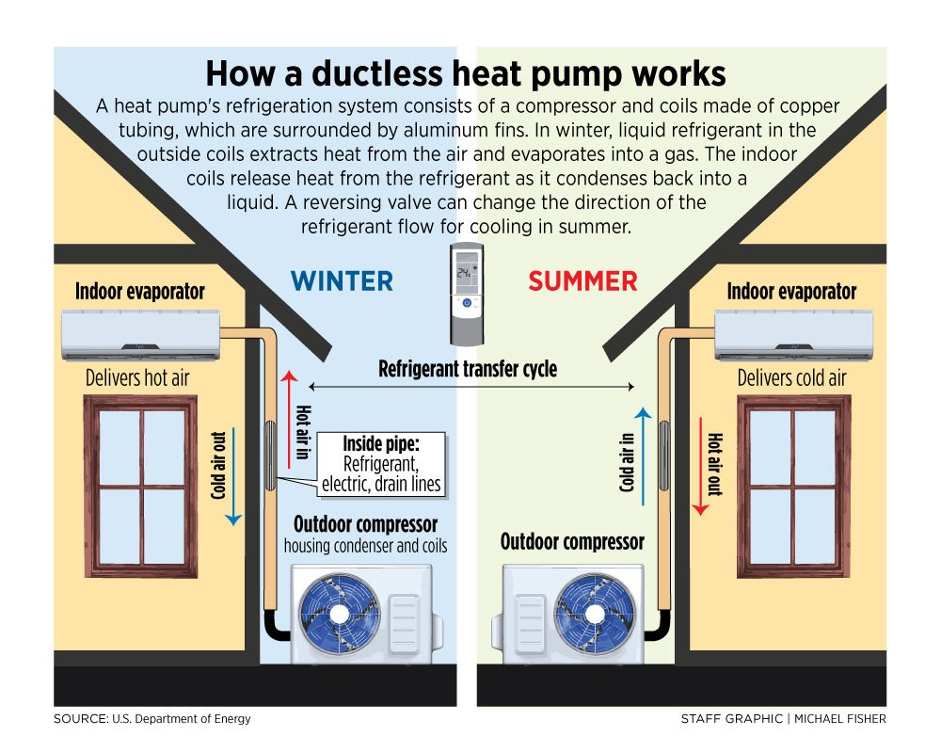

Comparison of Air Source and
Ground Source Heat Pumps

 | Air Source Heat Pumps |  | Ground Source Heat Pumps
 | Central Systems (Ducted) | Ductless Mini-Split Systems
Overview | Central systems connect to a single indoor unit (often a furnace), pushing air through a series of ducts, which gets exhausted through vents throughout a home. Central systems rely on an outdoor compressor/condenser. | Ductless mini-split systems consist of an outdoor compressor or condenser unit that connects to an indoor unit to distribute heat or AC throughout a home. | Ground source heat pumps, also referred to as geothermal heat pumps, extract heat from the ground during cold weather via an underground piping system, which is then distributed throughout your home. During warmer months, the process is reversed to provide cooling.
Life Expectancy | ~ 15 years | ~ 15 years | ~ 25 years
Most Common Fuel Source Options | Electricity | Electricity | Electricity
Benefits | - Can have a lower price point than ductless mini-splits (excluding ductwork installation)  - Heat and cool a home two to four times as efficiently as conventional heating and cooling systems, reducing utility bills  - Allow for control over an entire home’s temperature from a single thermostat  - Require no combustion, which eliminates carbon monoxide, making them safer than conventional heating and cooling options  - Can pair with solar PV and on-site storage options for electricity to reduce reliance on fossil fuel energy sources  - Produce fewer greenhouse gas emissions, contributing to a cleaner environment | - Heat and cool a home two to four times as efficiently as conventional heating and cooling systems, reducing utility bills  - Allow for customization and control of the temperature of each room in a home  - Require no existing ductwork  - Are less invasive and expensive than installing the ducting required for central systems  - Qualified models are optimized for New York weather conditions—look for a cold-climate model  - Small in size, providing design flexibility in home placement  - Require no combustion, which eliminates carbon monoxide, making them safer than conventional heating and cooling options  - Can pair with solar PV and on-site storage options for electricity to reduce reliance on fossil fuel energy sources  - Produce fewer greenhouse gas emissions, contributing to a cleaner environment  - Require minimal maintenance | - Act as one system to heat, cool, and supply hot water (if equipped with a desuperheater) for your home  - Provide more consistent, steady output and performance than air source heat pumps  - You can immediately save 30 to 60 percent on heating and 20 to 50 percent on cooling costs when switching from conventional heating and cooling systems (such as fuel oil, propane, and electric resistance systems)  - Require no combustion, which eliminates carbon monoxide, making them safer than conventional heating and cooling options  - Can pair with solar PV and on-site storage options for electricity to reduce reliance on fossil fuel energy sources  - Require minimal maintenance  - Produce fewer greenhouse gas emissions, contributing to a cleaner environment
Considerations | - If ductwork in a home is not present, ductwork would need to be installed | - Can have a higher price point than central heat pumps and conventional heating and cooling systems  - Can have higher installation costs than central heat pumps  - Depending on location and model, fans and compressors in the heat pump may be noisy | - Can have the highest price point relative to other heating and cooling options  - Homeowner must have sufficient space on property for installation
Operations and Maintenance | - Routinely replace or clean your air filters to lower your central heat pump’s energy consumption  - Check your heat pump’s evaporator coil every year and clean it as necessary  - Have a qualified contractor service the central heat pump once a year | - Clean or change filters once a month during peak usage times  - Have a qualified contractor service the heat pump at least once a year | - Clean or change filters once a month during peak usage times  - Have a qualified contractor service the heat pump at least once a year
Source: https://www.nyserda.ny.gov/Residents-and-Homeowners/Heat-and-Cool-Your-Home/Heat-Pumps

RMI :Heat Pumps: A Practical Solution for Cold Climates December 10, 2020 By Michael Gartman Amar Shah https://rmi.org/heat-pumps-a-practical-solution-for-cold-climates/?utm_medium=email&utm_source=spark&utm_content=spark&utm_campaign=2022_01_06
DOE Residential Cold Climate Heat Pump Technology Challenge, October 2021 file:///C:/Users/Gregory.000/Downloads/Building%20Electrification/DOE%20CCHP%20Tech%20Challenge%20Fact%20Sheet%2010-28-2021%20v2.pdf
Efficiency requirements for residential central AC and heat pumps to rise in 2023, July 30, 2019. https://www.eia.gov/todayinenergy/detail.php?id=40232
NJ 2019 Energy Master Plan, p. 158 https://nj.gov/emp/docs/pdf/2020_NJBPU_EMP.pdf

